Collision Avoidance project for a small vehicle or robot

Name: Ahmed Khaled Khalaf

* Conclusion:

The collision Avoidance project contains of Actuator and Ultrasonic sensor connected to a microcontroller which we programmed it, the function of the system is to assure that the vehicle will never collide to any obstacles.

* Case study:
* The system will check if there is any obstacle in front of it.
* If the obstacle is at a distance less than 50 meters, it will stop.

* Assumptions:
* System setup and shutdown procedure are not modelled.
* System maintenance is not modelled.
* The ultrasonic sensor never fails.
* DC motors never fail.
* System never faces power cut
* Method: for our project development cycle Waterfall Model was found to be the most suitable because of the low time and suitably to be done by one.
* Requirements diagram:



Space exploration: the project is quiet simple it doesn’t require more than one ECU contains Ultrasonic sensor, DC motor driver, and ATMEGA was found suitable for this project.

* 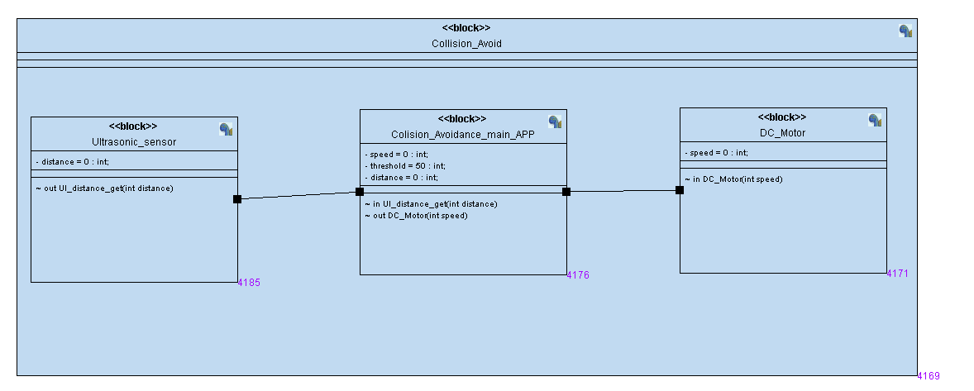Block
* machine for each block:
* 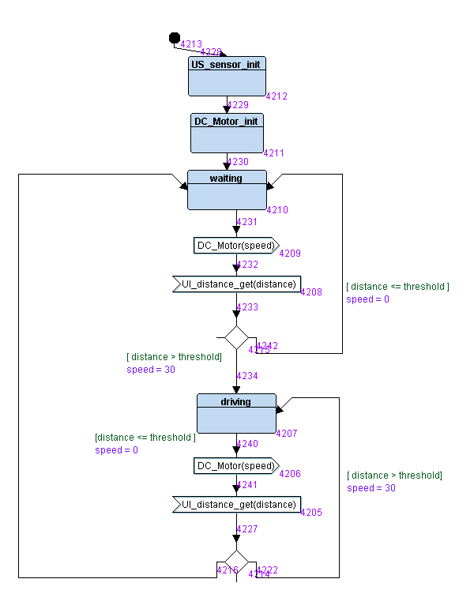 Collision Avoidance main:
* Ultrasonic sensor:

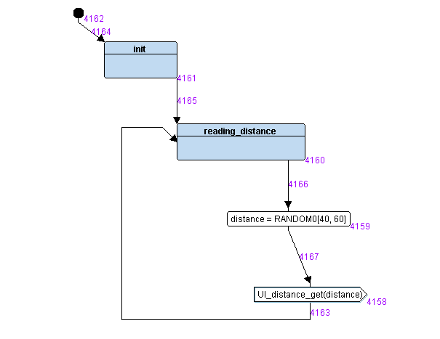

* DC Motor:

* Results:
* A diagram of a company

  Description automatically generated with medium confidenceSimulation:
* 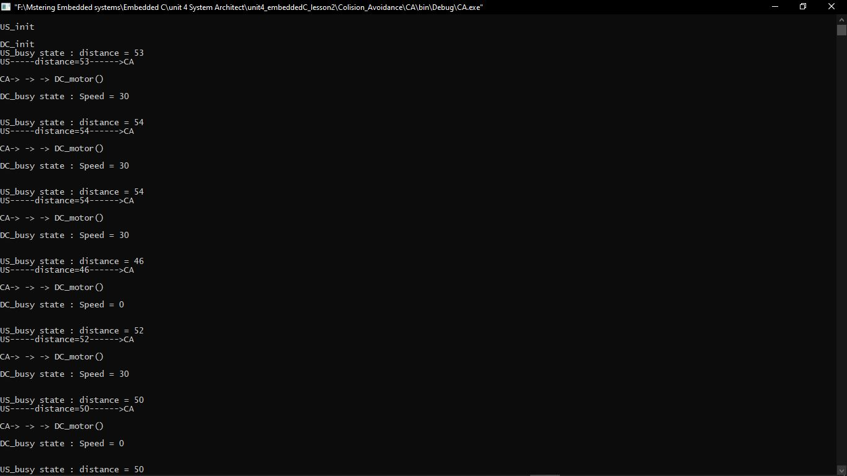Software: